Sample e-mail 1:
Subject: New Fight Corona Virus T-Shirt Designs
Dear ____,
First, thanks for being a customer and we hope you, your business and your family are all safe and healthy.
Second – we are still OPEN! And we’re partnering with custom t-shirt businesses around the country to share the WE’RE ALL IN THIS TOGETHER #LETSBEATCOVID19 message!

Imagine how your Team will feel wearing something encouraging – the conversations it could start, the personal connection you’ll be making with your team and they’ll be making with their customers.

Here’s how to get that positivity started:
Step 1: Choose your design below
Step 2: Get a list of sizes for your team
Step 3: Call and place your order!
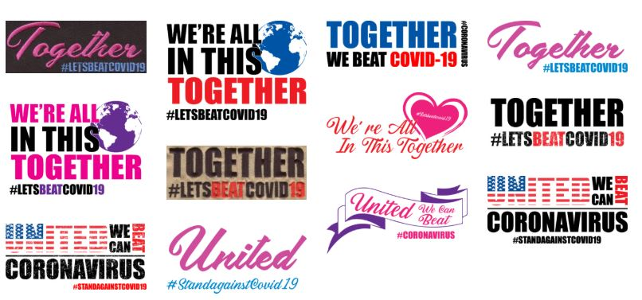

Just think – you will be supporting your Team AND our local business.

After all, we ARE in this together.

Sample e-mail 2:
Subject: Free T-Shirt to Inspire Your Employees AND Customers
THIS is the time to show your Team and your Customers that you’re still HERE – like we are. Still DOING business – like we are. And now more than ever that you appreciate your Team and that you appreciate your Customers coming in to keep your business going – like WE DO!
Here’s one way you do that today:
Give your Team a t-shirt they can wear to work that says what we ALL want to hear.
FIRST: Choose from one of our brand new WE’RE ALL IN THIS TOGETHER #LETSBEATCOVID19 t-shirt designs – they’re inspiring people all over the country.
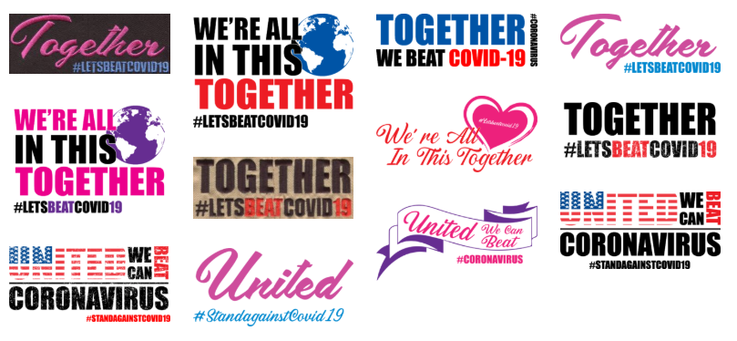
SECOND: Write down quantities and sizes.
THIRD: Just contact us to place the order – and we’ll have a surprise for you when you do! [Hint: we’ll include a FREE shirt or cap with every order over 12 so you can give away to your customers too!]

Sample e-mail 3:
Subject: Let’s show everyone how we’re in this TOGETHER – IN STYLE
I’m sending this message for a few quick reasons:
- Checking in on you. How are you? Is there something I can personally do to help? (sorry, I don’t have extra TP)
- Let you know I am STILL OPEN for your custom apparel needs.
- Share this positive message apparel decorators around the country are jumping on
We are all in this together. Everyone is stressed, maybe even a little scared. However, we have fought through so much in our lives to get to today, this isn’t going to stop us!
T-shirt shops and alike are working on a WE’RE ALL IN THIS TOGETHER #LETSBEATCOVID19 project.
If you want to participate here is what you can do:
- Buy a shirt for you
- Buy a shirt for a friend who needs to be lifted up
- I’ll GIVE a shirt for FREE to a nurse or first responder (Police, Fire, EMT)
I’ve reached out to the community to help locate those people who could use an uplifting message and of course everyone loves a free t-shirt.
This is my way of accomplishing 2 things:
- I want to help the people around me, and this is one way I can bring positivity
- I’d really like my business to survive through this and getting some orders will REALLY help!
Thank you all and #LETSBEATCOVID19 !!
Reply to this email or give me a call. I’m ready to start working on these!
See the Designs below:

